PRACTICAL – 9

BLACK-BOX & WHITE-BOX TESTING

Aim: Analyze Black-Box Testing, White-Box Testing, Integration Testing, and System Testing on a Sample Web Application

Test Scenarios

Scenario BB01

Scenario ID: BB01

Scenario: Black-Box Testing – Valid Login

Test Steps:

1.Open the login application in a browser.
2.Enter a valid email address.
3.Enter a valid password.
4.Click the Login button.

Test Input:

Email: admin@portal.com
Password: secret@123

Expected Result:

The system should accept valid credentials and display a successful login message.

Actual Result:

Login successful message is displayed.

Status:

PASS

Comments:

Valid login functionality tested successfully.
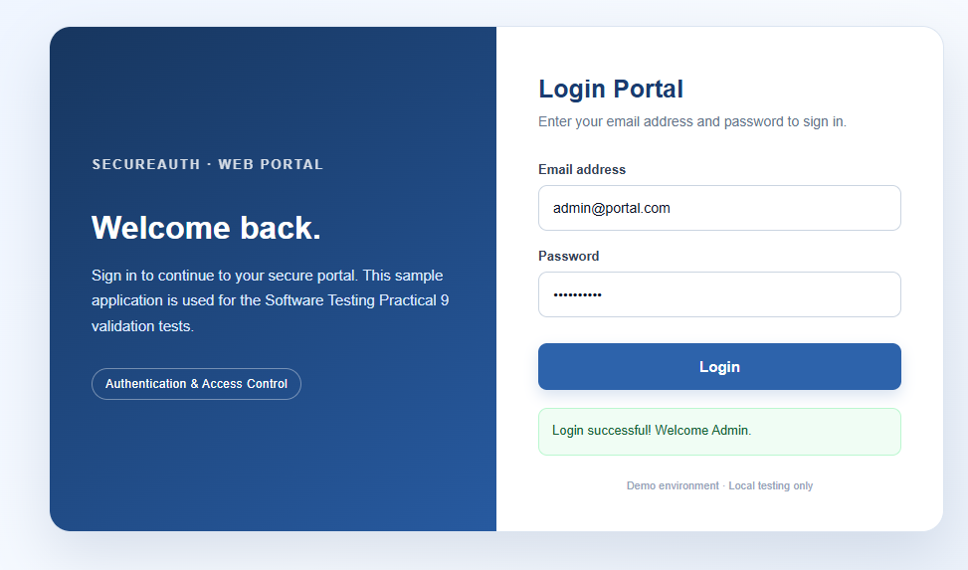

Scenario BB02

Scenario ID: BB02

Scenario:

Black-Box Testing – Invalid Email

Test Steps:

1.Open the login page.
2.Enter an invalid email address.
3.Enter a valid password.
4.Click the Login button.

Test Input:

Email: adminportal.com
Password: secret@123

Expected Result:

The system should reject the invalid email format and display a validation message.

Actual Result:

Invalid email validation message is displayed.

Status:

PASS

Comments:

Invalid email validation tested successfully.

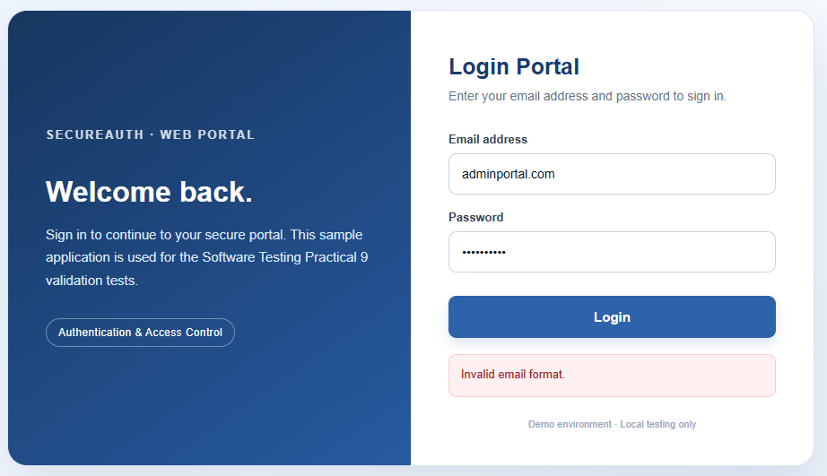
Scenario BB03

Scenario ID: BB03

Scenario:

Black-Box Testing – Blank Email

Test Steps:

1.Open the login page.
2.Leave the email field blank.
3.Enter a password.
4.Click the Login button.

Test Input:

Email: Blank
Password: secret@123

Expected Result:

The system should display a message indicating that the email field is required.

Actual Result:

Email validation message is displayed.

Status:

PASS

Comments:

Blank email validation tested successfully.
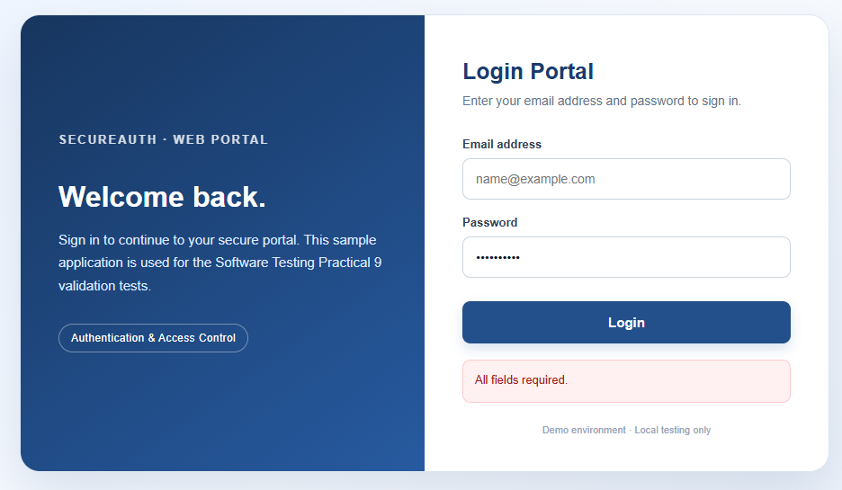

Scenario BB04

Scenario ID: BB04

Scenario:

Black-Box Testing – Blank Password

Test Steps:

1.Open the login page.
2.Enter a valid email address.
3.Leave the password field blank.
4.Click the Login button.

Test Input:

Email: admin@portal.com
Password: Blank

Expected Result:

The system should display a password-required validation message.

Actual Result:

Password validation message is displayed.

Status:

PASS

Comments:

Blank password validation tested successfully.

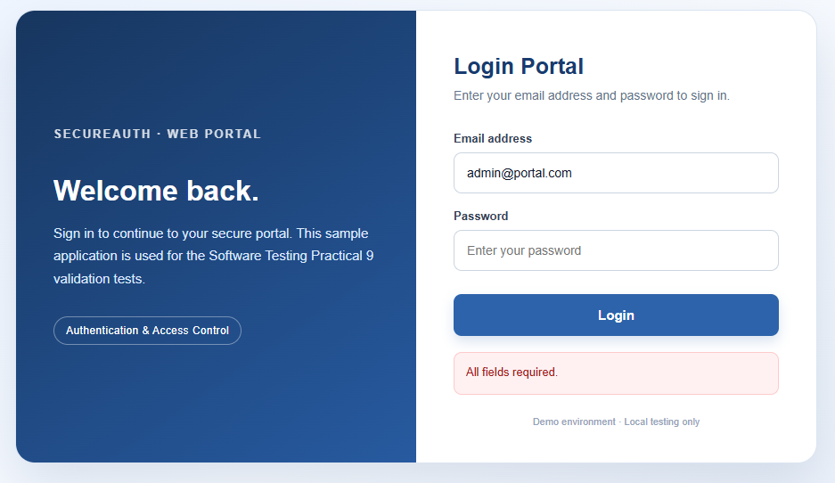
Scenario BB05

Scenario ID: BB05

Scenario:

Black-Box Testing – Incorrect Password

Test Steps:

- Open the login page.
- Enter a valid email address.
- Enter an incorrect password.
- Click the Login button.

Test Input:

Email: admin@portal.com
Password: wrong123

Expected Result:

The system should reject incorrect credentials and display an error message.

Actual Result:

Invalid credentials message is displayed.

Status:

PASS

Comments:

Incorrect password validation tested successfully.

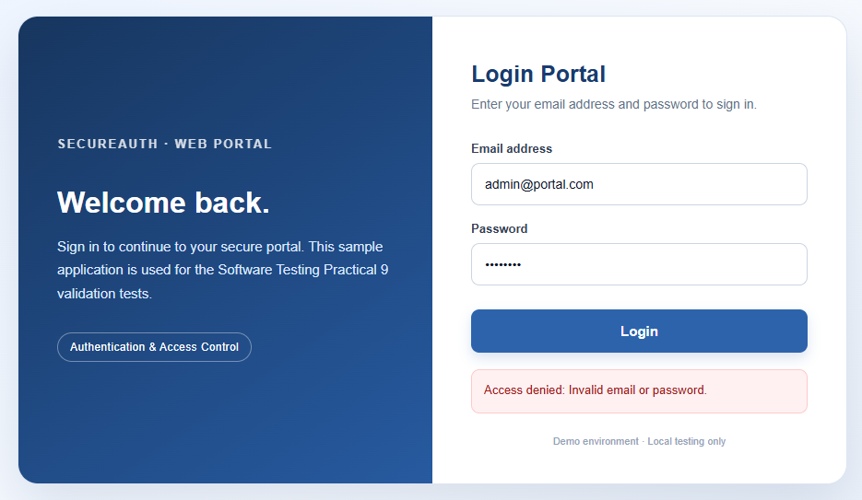

Scenario BB06

Scenario ID: BB06

Scenario:

Black-Box Testing – Short Password

Test Steps:

- Open the login page.
- Enter a valid email address.
- Enter a password shorter than the specified minimum length.
- Click the Login button.

Test Input:

Email: admin@portal.com
Password: abc

Expected Result:

The system should reject the short password and display a validation message.

Actual Result:

Password length validation message is displayed.

Status:

PASS

Comments:

Password length validation tested successfully.

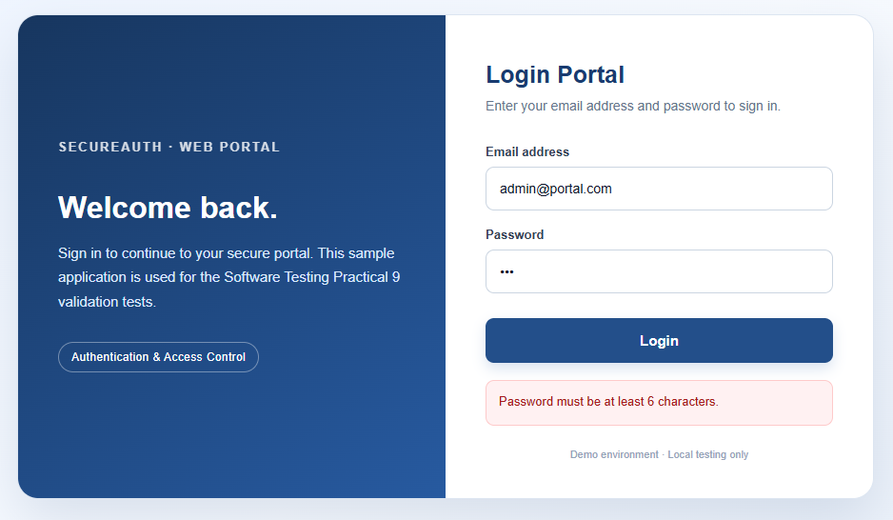

Scenario WB01

Scenario ID: WB01

Scenario:

White-Box Testing – Valid Condition

Test Steps:

- Open the login application.
- Enter a valid email address.
- Enter a valid password.
- Execute the login function.

Test Input:

Email: admin@portal.com
Password: secret@123

Expected Result:

All validation conditions should be satisfied, and the success branch should execute.

Actual Result:

Success branch executes correctly.

Status:

PASS

Comments:

Positive decision path verified.

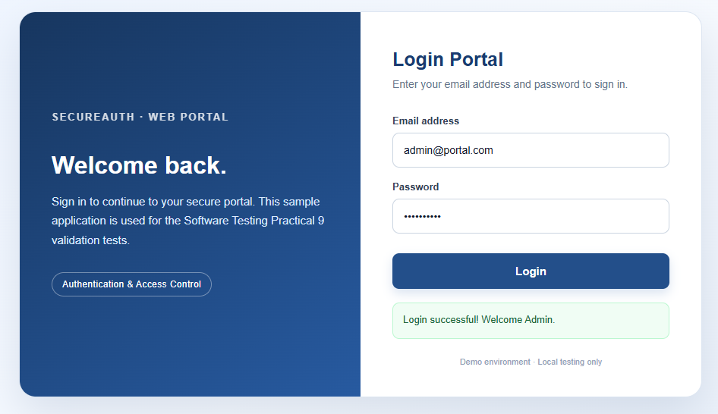

Scenario WB02

Scenario ID: WB02

Scenario:

White-Box Testing – Invalid Email Condition

Test Steps:

- Open the login application.
- Enter an invalid email address.
- Enter a valid password.
- Execute the login function.
Test Input:

Email: adminportal.com
Password: secret@123

Expected Result:

The email validation condition should fail, and the system should reject the input.

Actual Result:

Invalid email branch executes correctly.

Status:

PASS

Comments:

Negative decision path verified.

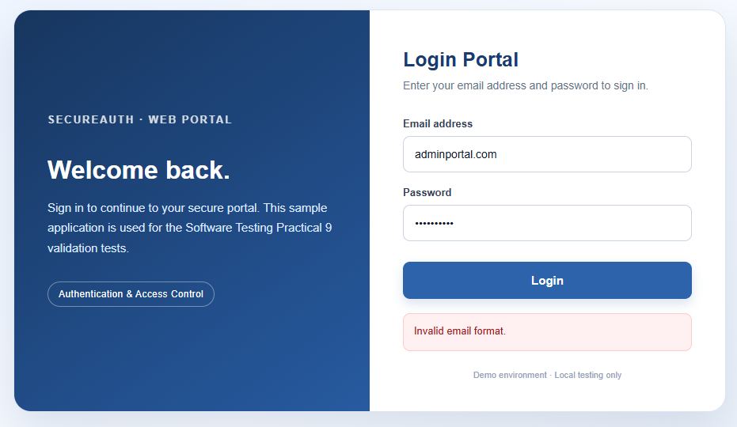
Scenario WB03

Scenario ID: WB03

Scenario:

White-Box Testing – Empty Field Condition

Test Steps:

- Open the login application.
- Leave one required field empty.
- Enter the remaining details.
- Execute the login function.

Test Input:

Email: Blank
Password: secret@123

Expected Result:

The empty-field condition should prevent login and display an appropriate validation message.

Actual Result:

Required-field validation is displayed.

Status:

PASS

Comments:

Empty-field decision branch verified.

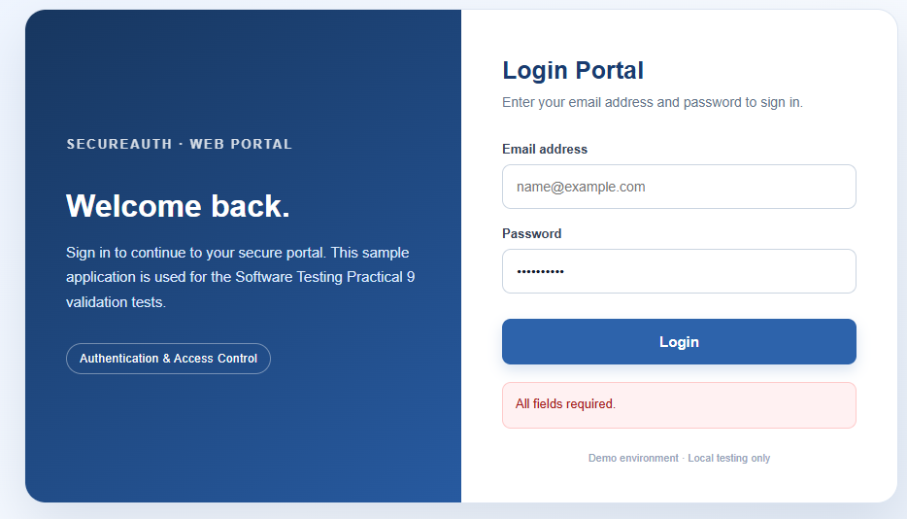
Scenario INT01

Scenario ID: INT01

Scenario:

Integration Testing – Form and Validation Function

Test Steps:

- Open the login page.
- Enter invalid input data.
- Click the Login button.
- Observe the validation message.

Test Input:

Email: adminportal.com
Password: secret@123

Expected Result:

The login form should correctly interact with the validation function and display the appropriate error message.

Actual Result:

Validation message is displayed correctly.

Status:

PASS

Comments:

Form and validation function integration tested.

Scenario INT02

Scenario ID: INT02

Scenario:

Integration Testing – Validation and Result Message

Test Steps:

- Open the login page.
- Enter valid credentials and submit.
- Observe the success message.
- Enter incorrect credentials and submit again.
- Observe the error message.

Test Input:

Valid credentials: admin@portal.com / secret@123
Invalid credentials: admin@portal.com / wrong123

Expected Result:

The application should display the correct message for both successful and unsuccessful login attempts.

Actual Result:

Appropriate success and error messages are displayed.

Status:

PASS

Comments:

Integration between validation logic and result messages verified.
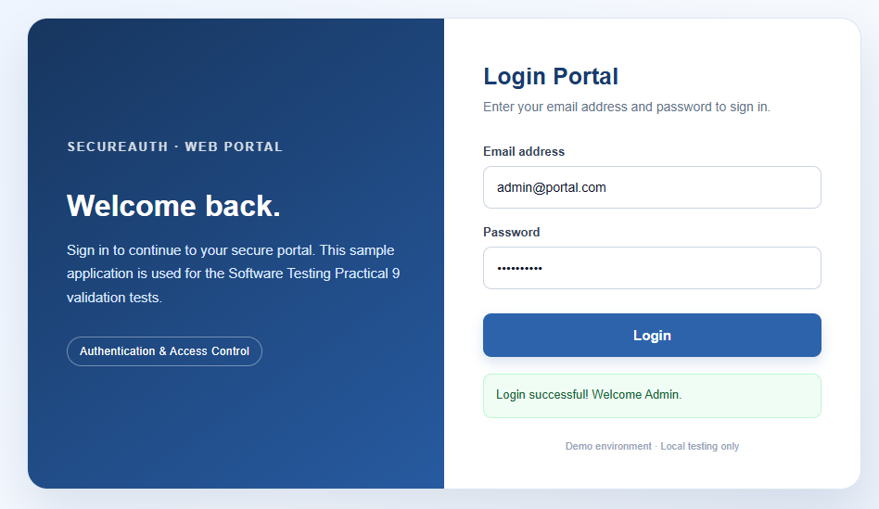

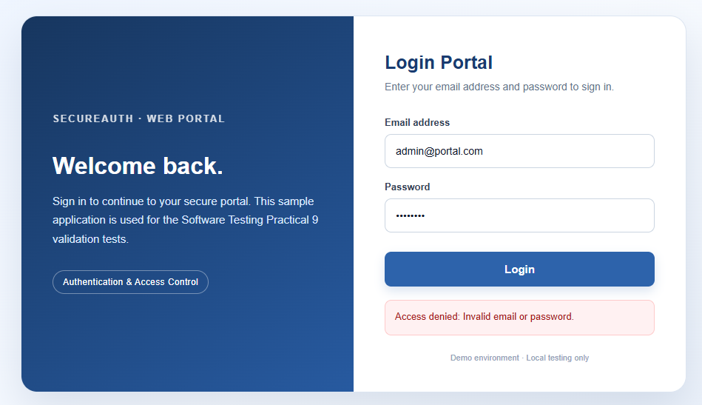
Scenario SYS01

Scenario ID: SYS01

Scenario:

System Testing – Successful Login

Test Steps:

- Open the application in Google Chrome.
- Enter valid login credentials.
- Click the Login button.
- Verify the displayed result.

Test Input:

Email: admin@portal.com
Password: secret@123

Expected Result:

The complete login process should work correctly and display a success message.

Actual Result:

The login process completes successfully.

Status:

PASS

Comments:

End-to-end successful login tested.

Scenario SYS02

Scenario ID: SYS02

Scenario:

System Testing – Unsuccessful Login

Test Steps:

- Open the application in Google Chrome.
- Enter a valid email address.
- Enter an incorrect password.
- Click the Login button.
- Verify the displayed result.

Test Input:

Email: admin@portal.com
Password: wrong123

Expected Result:

The system should deny login and display an appropriate error message.

Actual Result:

Login is denied, and an error message is displayed.
Status:

PASS

Comments:

End-to-end invalid login flow tested.

Conclusion:

The practical successfully demonstrates Black-Box Testing, White-Box Testing, Integration Testing, and System Testing on a sample web application. Different test cases were performed using valid and invalid inputs to verify the application's functionality, validation conditions, and error handling. The practical helped in understanding the importance of software testing in identifying defects and ensuring that the application works according to the expected requirements.

